RE: CRIMINAL RECORD CHECKS FOR ST. ALBERT MINOR HOCKEY ASSOCIATION

To Whom it May Concern,

This is to certify that has volunteered to coach in the 2021/22 hockey season. In their position within our organization, they will be providing leadership and guidance to minors.

Please feel free to contact me with any questions or concerns you may have.

Thank you,
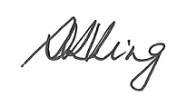
Seema King
Registrar, St. Albert Minor Hockey Association 780-242-0597/ registrar@samha.ca

Instructions for completing your Vulnerable Sector Check

- Visit https://rcmp.policesolutions.ca/checks/services/rcmpab-stalbert/

- Email a copy of the Vulnerable Sector Check to registrar@samha.ca; you must include your team number in the subject line

